Amazon Stock Analysis
This project focuses on analyzing stock price movements of Amazon using technical indicators. Historical stock data is collected from Yahoo Finance and processed in R to study trends, momentum, and potential trading signals.
The required libraries were installed and loaded to enable financial data analysis. Historical stock price data for Amazon was retrieved from Yahoo Finance using the quantmod package for the past three years. Missing values were removed to ensure clean and accurate analysis.
# Install required packages (run once) install.packages("quantmod") install.packages("TTR")

# Load libraries library(quantmod) library(TTR)

# Set date range (last 3 years) start_date <- Sys.Date() - 1095

# Get Amazon stock data from Yahoo Finance getSymbols("AMZN", src = "yahoo", from = start_date)
# Remove missing values amzn <- na.omit(AMZN)

Simple Moving Average

# Calculate Simple Moving Averages sma20 <- SMA(Cl(amzn), 20)
sma50 <- SMA(Cl(amzn), 50)
# Plot chart with SMA chartSeries(amzn,
name = "AMAZON – Simple Moving Average", theme = chartTheme("black"),
TA = "addSMA(20); addSMA(50)")
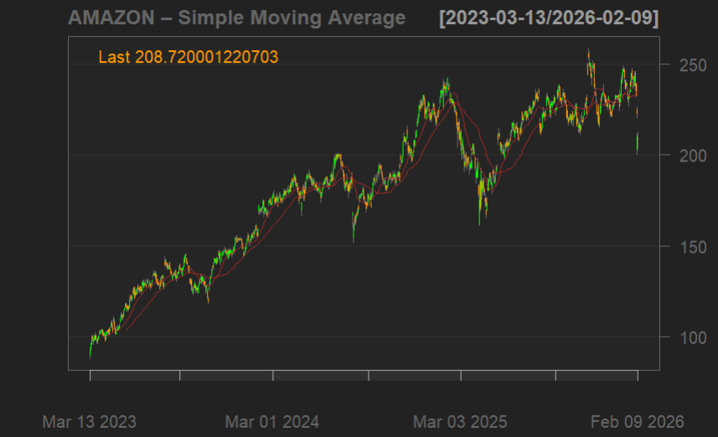

The chart shows Amazon’s stock price along with 20-day and 50-day simple moving averages. The 20-day SMA reacts faster to price changes and represents short-term trends, while the 50-day SMA reflects longer-term movement.
When the 20-day SMA crosses above the 50-day SMA, it indicates a bullish signal suggesting upward momentum. Conversely, when the 20-day SMA crosses below the 50-day SMA, it signals a bearish trend.
Over the observed period, Amazon’s stock shows an overall upward trend with intermittent corrections, and multiple SMA crossovers indicating changes in momentum.

RSI Chart

# Plot RSI chart chartSeries( amzn,
name = "Amazon – RSI",
theme = chartTheme("white"),
TA = "addRSI(n = 14)"
)
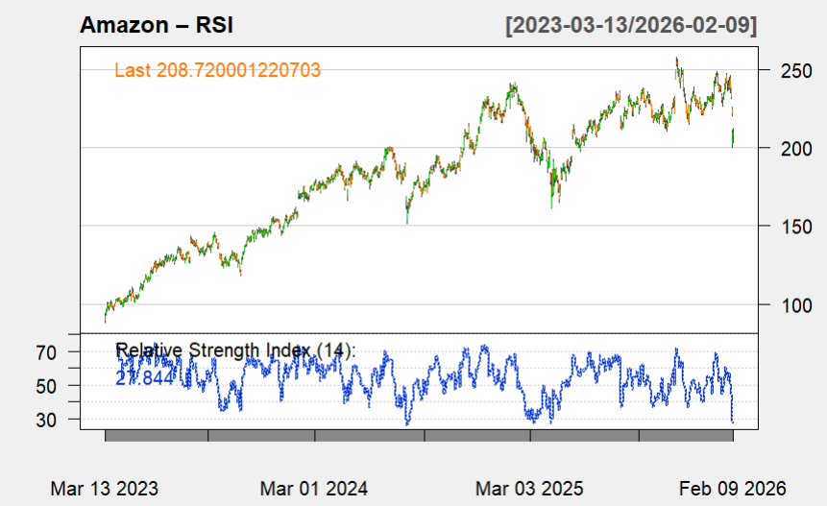

The RSI (Relative Strength Index) is used to measure the momentum of Amazon’s stock price and identify overbought and oversold conditions. An RSI value above 70 indicates that the stock may be overbought and could experience a price correction, while a value below 30 suggests oversold conditions and potential upward movement.
From the chart, the RSI fluctuates within the 30–70 range for most of the period, indicating relatively stable momentum. Occasional spikes above 70 suggest short-term overbought conditions, while dips below 30 indicate potential buying opportunities.

MACD Line

# Plot MACD with histogram chartSeries(
amzn,
name = "Amazon – MACD with Histogram",
theme = chartTheme("white"),
TA = "addMACD(fast = 12, slow = 26, signal = 9, type = 'EMA', histogram = TRUE)"
)

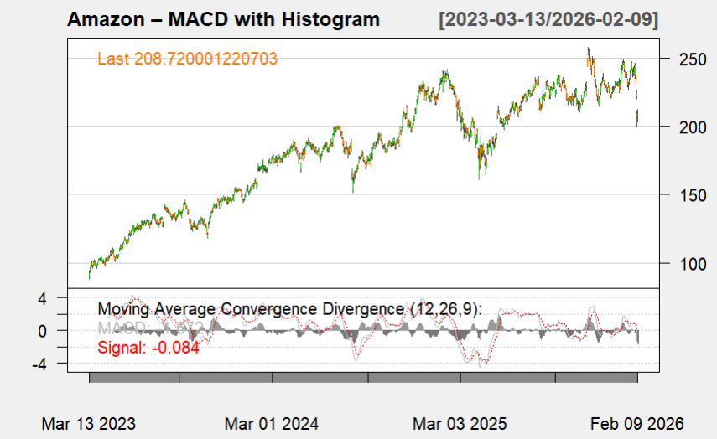

The MACD (Moving Average Convergence Divergence) indicator is used to identify momentum and trend direction in Amazon’s stock price. A bullish signal occurs when the MACD line crosses above the signal line, indicating increasing upward momentum. Conversely, a bearish signal occurs when the MACD line crosses below the signal line, suggesting downward momentum.
The histogram represents the difference between the MACD and signal lines and helps visualize the strength of the trend. Positive histogram values indicate bullish momentum, while negative values reflect bearish pressure.
From the chart, multiple crossovers can be observed, highlighting shifts in momentum. These signals, when combined with other indicators, can help identify potential entry and exit points.

Bollinger Bands
# Plot Bollinger Bands chartSeries(
amzn,
name = "Amazon – Bollinger Bands",
theme = chartTheme("white"),
TA = "addBBands(n = 20, sd = 2)"
)
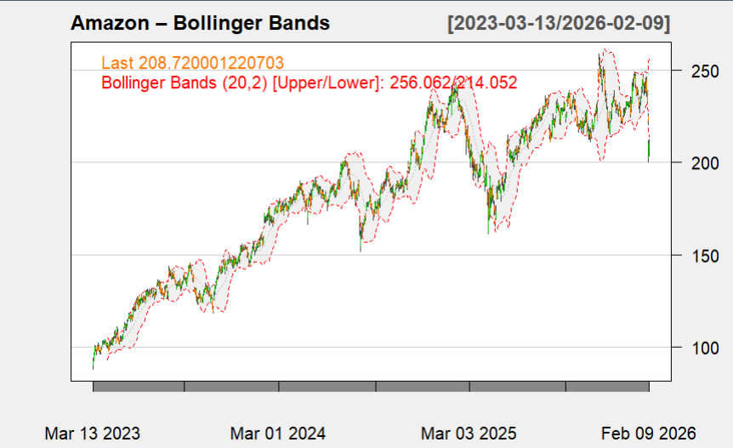

Bollinger Bands are used to measure price volatility and identify potential overbought or oversold conditions. The bands consist of a moving average and two standard deviation lines above and below it.
When the stock price approaches or touches the upper band, it may indicate overbought conditions, suggesting a possible price correction. Similarly, when the price nears the lower band, it indicates oversold conditions and potential upward movement.
From the chart, Amazon’s stock price frequently moves within the bands, with occasional touches near the upper and lower limits. The widening of bands indicates periods of high volatility, while narrowing bands suggest lower volatility and consolidation phases.

Trading Signal Generation and Strategy
macd <- MACD(Cl(amzn))
rsi <- RSI(Cl(amzn))

signal <- ifelse(
sma20 > sma50 & macd$macd > macd$signal & rsi < 70,
"BUY",
ifelse(
sma20 < sma50 & macd$macd < macd$signal & rsi > 30,
"SELL",
"HOLD"
)
)

returns <- dailyReturn(Cl(amzn))
A rule-based trading strategy was developed by combining multiple technical indicators to generate buy, sell, and hold signals. The strategy integrates trend (SMA), momentum (MACD), and overbought/oversold conditions (RSI) to improve decision-making.
A buy signal is generated when the short-term trend is stronger than the long-term trend, momentum is positive, and the stock is not overbought. Similarly, a sell signal is generated when the trend weakens, momentum turns negative, and the stock shows signs of downward pressure.
Daily returns were calculated to analyze stock price changes and evaluate the effectiveness of the strategy.

‘

Full Chart Series
#Plot ChartSeries
chartSeries(
amzn,
name = "Amazon – Full Chart Series",
theme = chartTheme("white"),
TA = c(
"addSMA(20, col='blue')",
"addSMA(50, col='red')",
"addBBands(n=20, sd=2)",
"addRSI(n=14)",
"addMACD(fast=12, slow=26, signal=9, histogram=TRUE)"
)
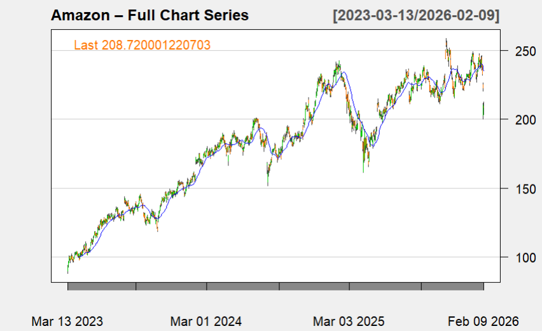

The combined chart integrates multiple technical indicators to provide a comprehensive view of Amazon’s stock behavior. The moving averages indicate the overall trend, while RSI highlights momentum and potential overbought or oversold conditions. MACD confirms changes in momentum and trend reversals, and Bollinger Bands reflect periods of high and low volatility.
By analyzing these indicators together, stronger and more reliable trading signals can be identified. The alignment of trend, momentum, and volatility indicators helps reduce false signals and improves decision-making compared to relying on a single indicator.

